Python boot camp project:

Bulk SMS sender

# Project Description:

In our python boot camp, we created a bulk SMS sender as a project by using the services of Twilio REST API’s trial version. We used the learned concept of classes in our project, while learning the concept of abstraction while making the project. We abstracted the complex implementation details from the user as he can send the message only by inputting message text and the recipient’s number.

# Twilio REST API Details:

## Signing up on Twilio:

Signup on twilio’s trial account to get started.

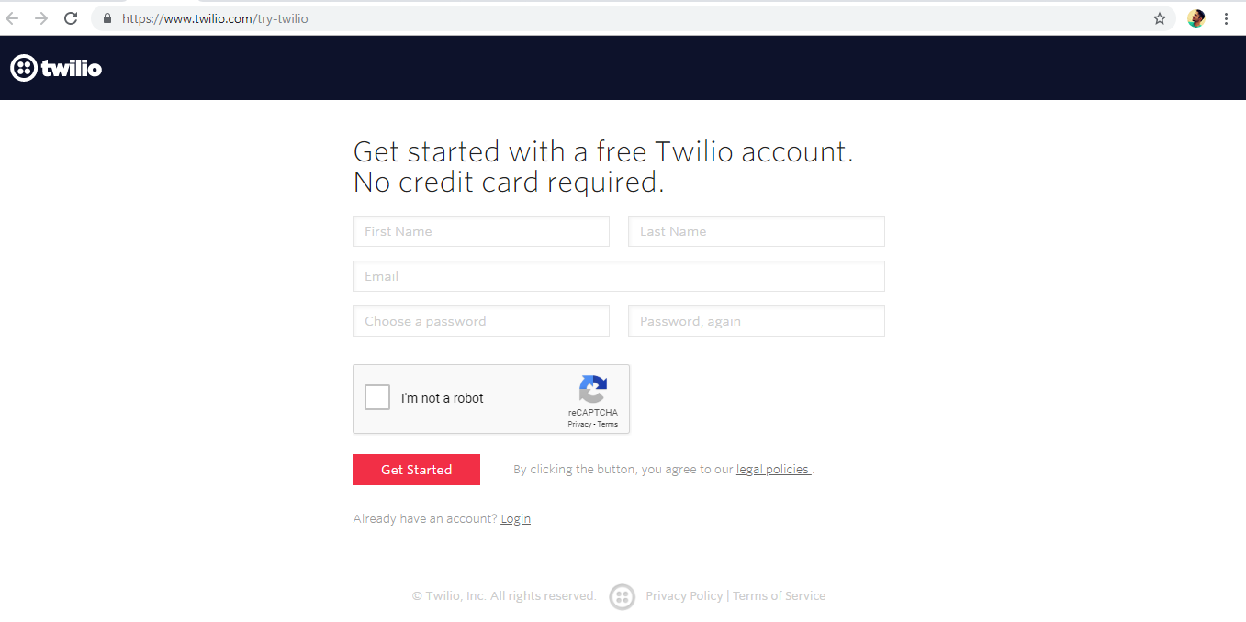

**Fig: 01 Twilio trial account sign up screen.**

## Getting phone number to send messages:

Please have a read at this link:

<https://www.twilio.com/docs/sms/quickstart/python#sign-up-for-twilio-and-get-a-phone-number>

## Install Python and the Twilio Helper Library:

Please have a read at this link:

<https://www.twilio.com/docs/sms/quickstart/python#install-python-and-the-twilio-helper-library>

## Send an outbound SMS with Python using twilio rest API:

Please have a read at this link it has the required code in which you would make changes along with good explanation.

<https://www.twilio.com/docs/sms/quickstart/python#send-an-outbound-sms-with-python>